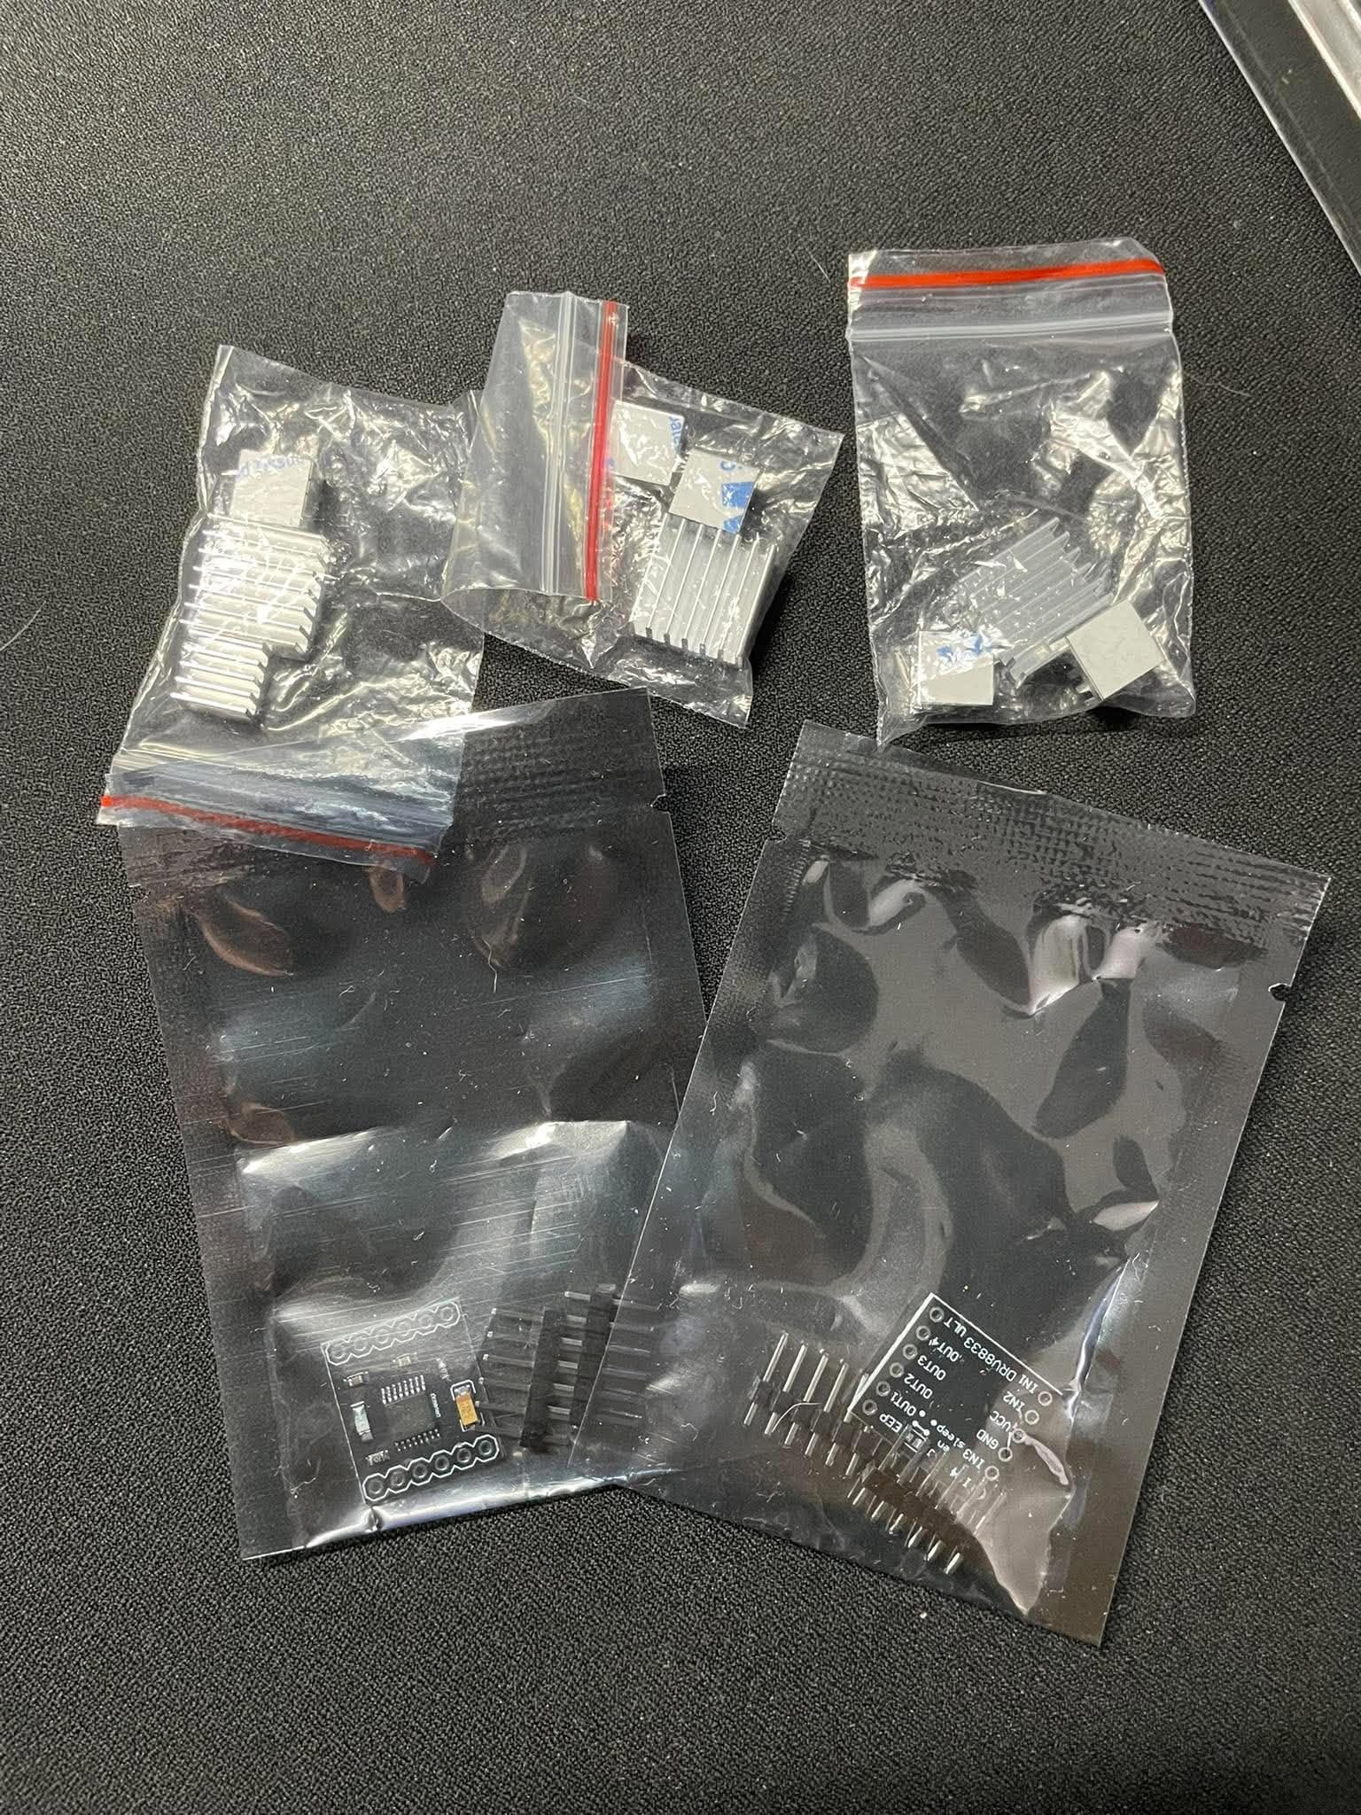

The pictures also present the additional hardware components required for the fabrication and development of the prototype system. These components serve different functions within the system and are selected based on their compatibility, functionality, and suitability for the intended application.
OTHER COMPONENTS NEEDED

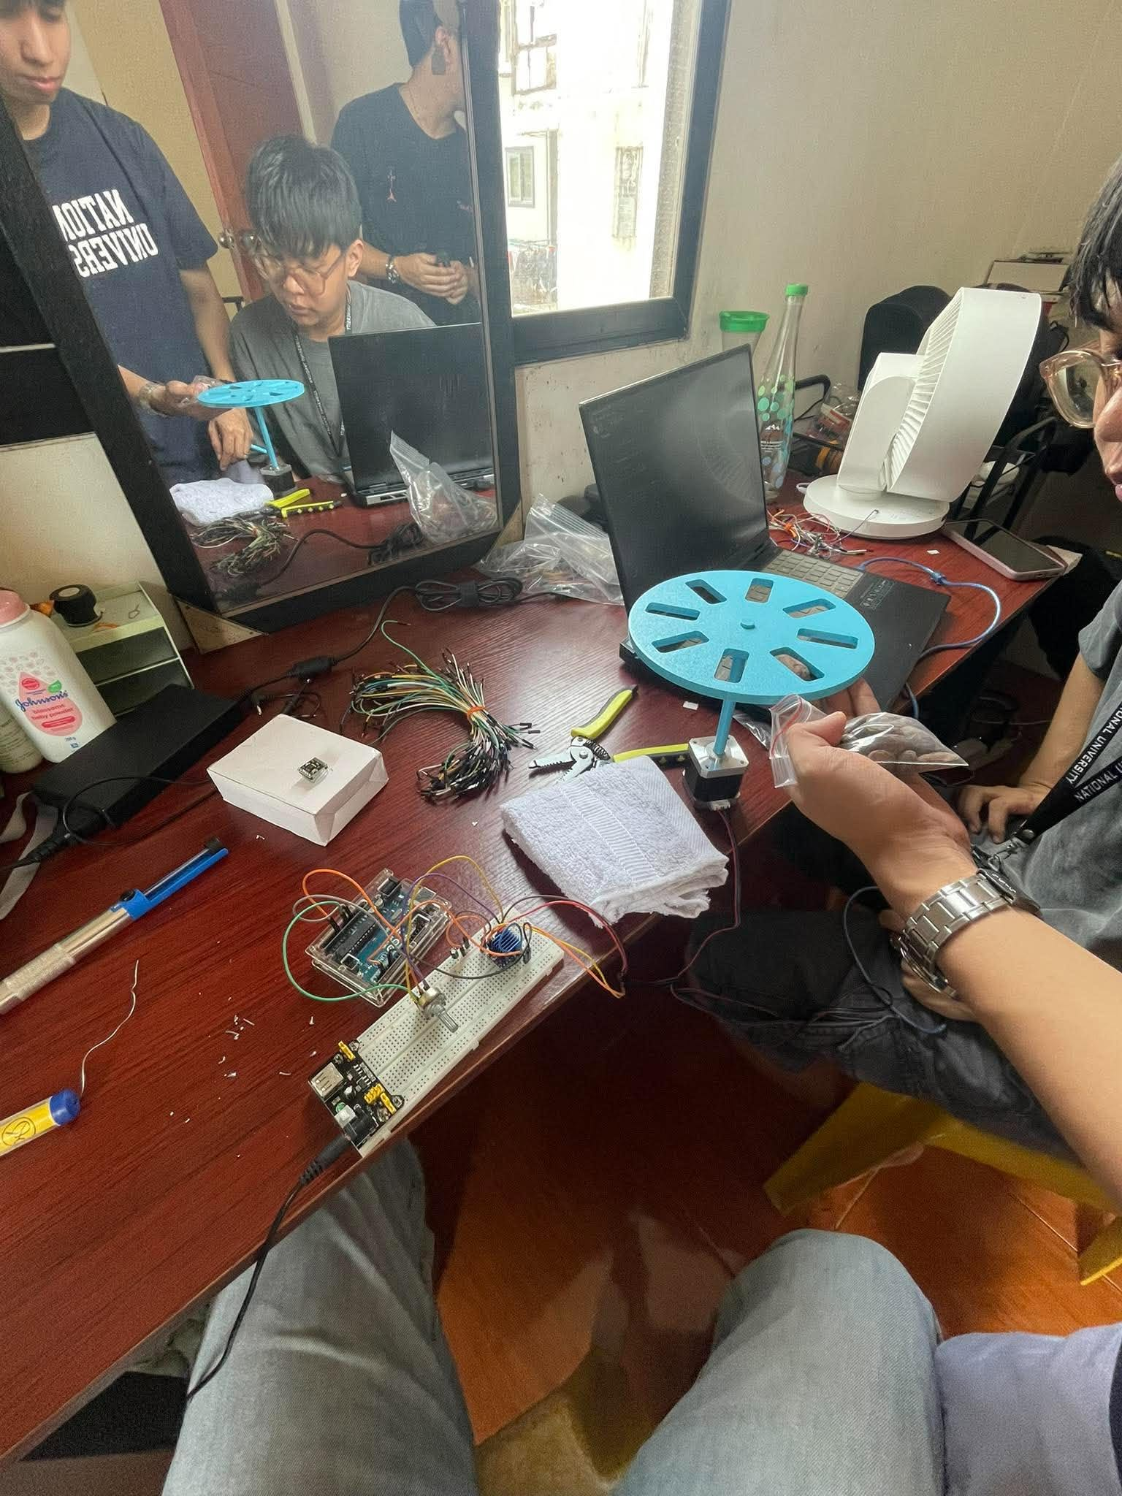
The pictures show the fabrication of the hardware components for the system, including the assembly of various parts and the testing of individual components.
HARDWARE FABRICATION/SETUP

